 | The CAMECA IMS 7f and 4f-E7 Software user’s guide  Mass Calibration  00 45 633 904 - Type 108 – Indice A
0000.doc

Index

Contents

1. Introduction 1
1.1 The mass calibration principles 1
1.2 The M-B memory effect 2
1.3 The cycling strategy 2
1.4 The analysis mass calibration b(m) table 3
1.5 The k(B) and B(M) tables 3
2. Mass calibration windows 5
2.1 Tuning related functions 5
2.2 Analysis related functions 7
2.3 Mass calibration display window 7
2.3.1 K-B tools window 10
2.4 Mass calibration routine: mass cal window 15
2.4.1 Manual mode 16
2.4.2 Semi-auto mode 18
2.4.3 Automatic mode 27
2.5 Mass calibration cycling window 29

Contents ↑

Introduction

The mass calibration principles

It is explained in the secondary ion optics user's guide/magnet and mass calibration issue that the magnetic field set value which is expected to produce a given mass at the center of the spectrometer exit slit depends coarsely on the instrument and on the secondary voltage, but for a high resolution precision, because of a memory effect, it depends also on the mass cycle.
The so-called mass calibration routine is the practical solution for addressing correctly the required mass along a tuning or analysis process. The mass calibration process is targeted to determine as precisely as possible the magnetic field value B which will give the requested mass M at the exit slit center.

The mass calibration involves several tables:
- k(B): specific to each instrument, it is used to generate the B(M) table.
- B(M): main mass calibration table. The mass calibration routine uses the B(M) table to set the magnetic field B for any mass M (see The k(B) and B(M) tables).
- b(m): analysis mass calibration table. When the mass calibration routine is achieved just before starting an analysis, the output b_{i} values (i=1..N and N is the total number of analyzed species) fill the analysis species table b(m) (see The Analysis mass calibration b(m) table).

The mass calibration defines the field B to the magnet control system for each mass

Contents ↑

The M-B memory effect

It must be first emphasized that while M is the exact mass which is expected on the axis at the exit slit plane, B is not the actual magnetic field within the magnet, which is not a single value, but a distribution along the main path. B is the input value sent to the surveyed system which controls the magnet supply with the constraint that the difference between B and the Hall probe output measurement is zero.

For different physical reasons, magnet hysteresis, Hall sensor thermal effects, eddy currents, the mass M which results from addressing B to the magnet supply depends on the last {... B_{t-3}, B_{t-2}, B_{t-1}} history.
The issue is to determine the value B which will set the required mass M onto the exit axis. The above memory effect produces an uncertainty onto the relationship B(M).

Contents ↑

The cycling strategy

This last uncertainty is dramatically reduced when the same B series (B_{min}, B₂... B_{i},... B_{max}) is cycled, and providing that the successive B values are growing from B_{min} to B_{max}. After a few number of cycles, the value of the mass produced at the exit axis reaches a steady state, and its uncertainty can be reduced down to a few ppm.

Fortunately, it is possible to keep regular B cycles over an analysis. The mass calibration strategy consists therefore in calibrating the values B_{i} associated to the respective masses M_{i} while cycling B according to the analysis cycle and to avoid to get out of the cycle between the mass calibration and the analysis.
If a high mass resolution is required, each time the analysis cycle is broken, the mass calibration must be performed again.

From the mass calibration stage up to the end of the analysis, the instrument must be kept in the same analysis B field cycle

Contents ↑

The analysis mass calibration b(m) table

The analysis mass calibration routine involves a b(m) table different from the current B(M) table. This b(m) table is initialized when the operator defines the species to be analyzed. Along the mass calibration process the b_{i} values are modified, and at the end of the process, the modified b_{i} values are sent back to the analysis species table.
So, when called from Analysis, the mass calibration routine modifies the b(m) table whereas it may or not modify the main B(M) table depending on the choice of the operator. The value of the Setup parameter #617 is set by default to 0, meaning that the output b_{i} values are not sent to the B(M) table. The operator may change its value to 1, so that the B(M) table is updated whenever an analysis mass calibration routine is achieved.

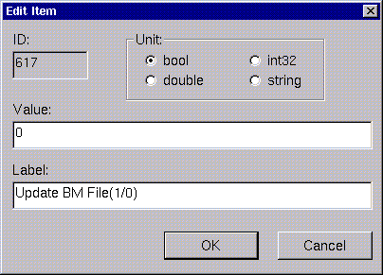

The mass calibration routine, when called from Analysis may or not modify the current B(M) table, depending on the setup parameter #617 value.

Contents ↑

The k(B) and B(M) tables

The k(B) table is used to generate a B(M) table, since the practical relationship between the required magnetic field B and the selected mass M is

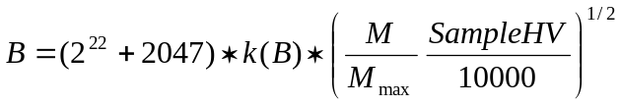 (1)

where SampleHV is the sample extraction voltage and k(B) is a coefficient very close to 1 which depends on the B field value.
The k(B) table is specific to each instrument and is defined during the factory setting of the instrument. Two k(B) files are stored in the instrument computer corresponding respectively to the negative and the positive polarity. Each k(B) file stores the k(B) table which contains up to 16 (B, k) points and also the value of M_{max}.

Once the k(B) table is correctly filled, the basic relationship (1) allows to reconstruct the mass calibration table B(M) at any secondary extraction voltage with an accuracy better than 1/1000. A mass calibration control is however strongly recommended before any analysis.
The B(M) table is reinitialized from the k(B) table whenever the SampleHV is modified or a secondary polarity switching is achieved. At the initialization step, 16 values for the magnetic field B are computed for the integer masses

1 | 11 | 14 | 23 | 28 | 44 | 56 | 75 | 84 | 112 | 133 | 161 | 197 | 224 | 266 | 399

The computation of each of these 16 B(M) points involves a cubic spline interpolation of the k(B) table. An elementary iterative algorithm is also required since the formula (1) is not explicit.

Once these 16 B(M) points have been defined, any mass M can be addressed using directly the B(M) table. Masses are called, either in the Tuning program (Mass & Slits preset box) or in the Analysis program, once the operator enters either a symbol or a mass value. The computer then returns the magnetic field value B calculated from the B(M) table.
In the B(M) table the stored masses are always integer: let’s suppose M₀ is the closest integer value to the requested mass M. For the mass M, the magnetic field B is calculated according to one of the following rules:
- M₀ belongs to the B(M) table. In this case, the magnetic field B returned for the requested mass M is calculated from the simple relationship B = B₀ * (M / M₀)^{1/2}, where B₀ is the magnetic field stored for the mass M₀.
- M₀ does not belong to the B(M) table. The magnetic field B for the requested mass M is computed using a cubic spline interpolation of the magnetic field values stored for the four masses in the B(M) table which are the closest to the requested mass M.

The operator can add new points to the B(M) table by a mass calibration action, using:
- the direct calib function in the Mass & Slits preset box of the Tuning program (see Procedure to use the direct calib button).
- the mass calibration routine (see Mass calibration routine: mass cal window) if the mass calibration program is called from the Tuning program. If the mass calibration routine is called from the Analysis program, the validated B field values are added to the B(M) table only if the setup parameter #617 is set to 1 (see The analysis mass calibration b(m) table).

As the B(M) table works with integer mass values only, once the operator sends to the B(M) table a magnetic field value B for a given mass M, the mass and magnetic field values that are effectively stored are respectively M₀, the closest integer value to the mass M, and the magnetic field B₀ = B * (M₀ / M)^{1/2}. If the mass M₀ already belongs to the B(M) table, the old magnetic field value set to this mass is replaced by the new magnetic field value B₀.

Adding points to the B(M) table can be helpful since it increases the accuracy of the mass calibration for masses close to the extra points. Note however that the new B(M) points are stored only as long as the sampleHV is not modified. Next time the same sample extraction field will be set in the instrument, the B(M) table will be recalculated from the k(B) table, and the B values will be computed for 16 integer masses only.

Only the k(B) tables (one for negative and the other for positive polarity) are stored in the computer.

Note: It is possible to update the k(B) files by fitting the k(B) values to an enriched B(M) table by inverting expression (1). This is a non-standard operation and should be performed by an expert user only (see Procedure to create a new k(B) table).

Contents ↑

Mass calibration windows

The mass calibration program can be called either from the Tuning program (call calib in the calib menu, Mass & Slits preset box) or from the Analysis program (calib now in the calibration menu, in the Analysis definition window).

Once the calibration program is opened, three main function modes are proposed to the operator:
- Display: B(M) and k(B) tables are displayed, and can also be modified.
- Mass cal: gives access to the mass calibration routine, which sets the B field value to the requested mass(es).
- Cycling : cycles the magnetic field over the B field values in the Analysis species table.

Each one of these main functions can be selected by pressing the corresponding button: mass cal, display, or cycling present in the top of the mass calibration window.

Contents ↑

Tuning related functions

In the Tuning program, the direct calib button and the calib menu are dedicated to mass calibration functions.

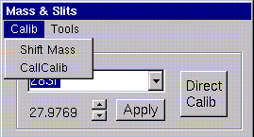

The direct calib button is very commonly used since it allows to quickly calibrate a mass. It is equivalent to a manual mass calibration routine.

procedure to use the direct calib function

- Enter a mass in the Mass & Slits preset box.
- Using the keyboard mass thumbwheel, tune the magnetic field value B in order to have the right mass M at the exit slit center.
- Press the direct calib function in the calib menu of the Mass & Slits box. This new B(M) point is transmitted to the B(M) table.

Functions available in the calib menu:
- Call calib calls the mass calibration program.
- Shift mass applies an overall shift to the mass calibration table, by tuning one reference mass only. The shift mass function should be used if there is a shift, over the whole mass range, of the magnetic field returned by the mass calibration with respect to the magnetic field giving the right mass in the exit slit. Applying a shift corresponds to updating the value of M_{max} in the k(B) file.

procedure to apply a mass calibration shift

- Enter a mass in the Mass & Slits preset box and then, using the keyboard mass thumbwheel, tune the magnetic field value B in order to have the right mass M at the exit slit center.
- Select the shift mass function in the calib menu of the Mass & Slits box. From the shift of B field found for this reference mass, a new value of M_{max} is calculated:

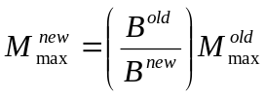

so that relationship (1) remains valid. The new value of M_{max} is stored in the k(B) file of the working polarity. The magnetic field values for all B(M) points are updated using relationship (1) in order to take into account the new value of M_{max}.

Contents ↑

Analysis related functions

In the Analysis program, the calibration menu is dedicated to mass calibration functions.
- Calib now calls the mass calibration program.
- Read table updates the magnetic field values for the masses entered in the species table by computing them from the B(M) table.

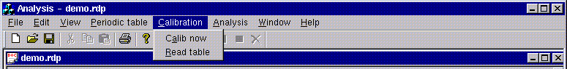

Contents ↑

Mass calibration display window

The mass calibration display window gives access to the following functions:
- Graphic display of the B(M) points. Straight lines connecting the points are also displayed for clearness sake. The operator can perform a zoom in the B(M) curve window and choose between lin and log scales.
- Deletion of B(M) points.
- Printing of the B(M) curve.

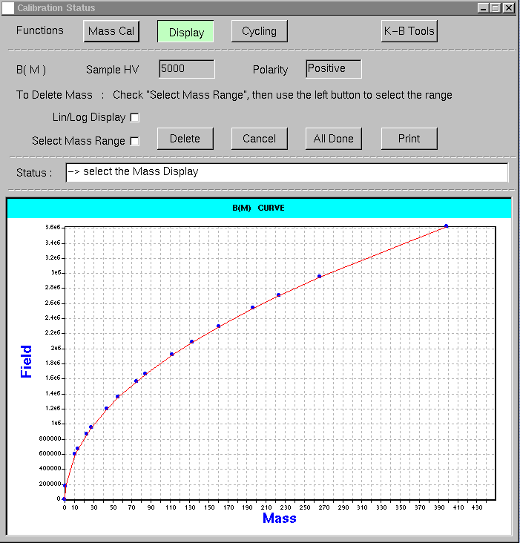

- Sample HV and polarity read-only fields: indicate respectively the sample extraction voltage and the secondary polarity. These values can be modified through the Tuning program only.
- Lin/log display check box: allows to switch between linear and logarithm scale for the B(M) curve display. Leave this box unchecked to have a logarithm scale, or check this box to have a linear scale.
- Select mass range check box: allows to mouse select a given mass range. The B(M) point(s) included in this mass interval can then be deleted.
- Delete button: allows to delete B(M) point(s) included in a previously selected mass range (see procedure to delete B(M) points below).
- Cancel button: cancels the mass range selection, the operator can then restart the select mass range procedure.
- All done button: closes the mass calibration program, all changes performed by the operator are kept.
- Print button: opens the printing dialog box, it allows the printing of the B(M) curve.
- Status box: displays messages to guide the operator in performing the display window operations.
- B(M) curve: the B(M) curve is plotted in the bottom of the mass calibration display window. A zoom can be performed in this curve by directly using the mouse (see below).

procedure to apply a zoom in the b(m) curve

- Once the mass calibration program is opened, press display button.
- If required, switch from logarithm to linear scale by checking lin/log scale check box.
- Set the mouse cursor in the B(M) curve area, on the point corresponding to a corner of the area to be zoomed.
- Press the left mouse button. The mouse cursor becomes a drag symbol.
- Drag the mouse cursor. A black colored box is drawn.
- When the box frames the area to be zoomed, release the left mouse button. The boxed area is displayed full window.
Note: In order to undo a zoom, click right mouse button on any point of the B(M) curve area.

procedure to delete b(m) point(s)

- Once the mass calibration program is opened, press display button.
- If required, switch from logarithm to linear scale by checking lin/log scale check box.
- If required, zoom in the B(M) curve.
- Check select mass range check box.
- Set the mouse cursor in the B(M) curve area, on a point corresponding to the low limit of the mass range to be deleted.
- Press the left mouse button. The mouse cursor becomes a drag symbol.
- Drag the mouse cursor until the higher limit of the mass range to be deleted is reached.
- Release the left mouse button. A black boxed column is displayed (see figure below). The width of the column corresponds to the selected mass range.
- If required, press cancel button to undo the mass range selection, and then restart from step #5.
- Press delete button. A confirmation prompt appears. If the deletion is confirmed, the B(M) points whose mass M is included in the selected mass range are deleted from the B(M) table.

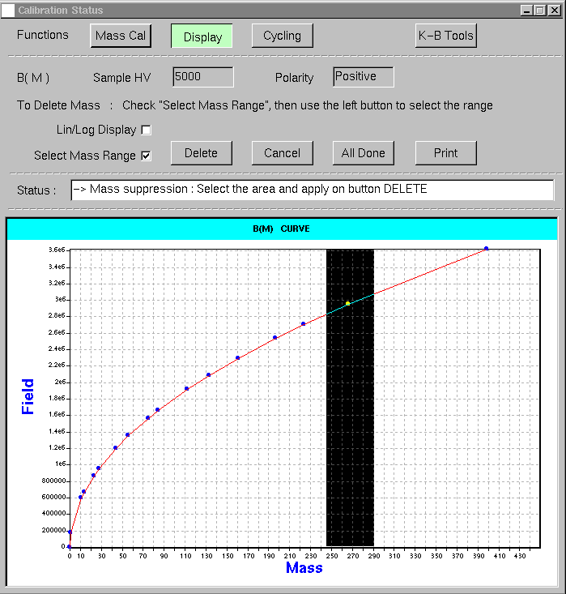

Contents ↑

K-B tools window

The mass calibration k-B tools window displays the k(B) and B(M) tables and gives access to more advanced operations involving the k(B) and B(M) tables.
The k-B tools window opens when pressing the k-B tools button in the mass calibration display window. The k-B tools window can be closed by pressing close button on the bottom right corner of the k-B tools window.

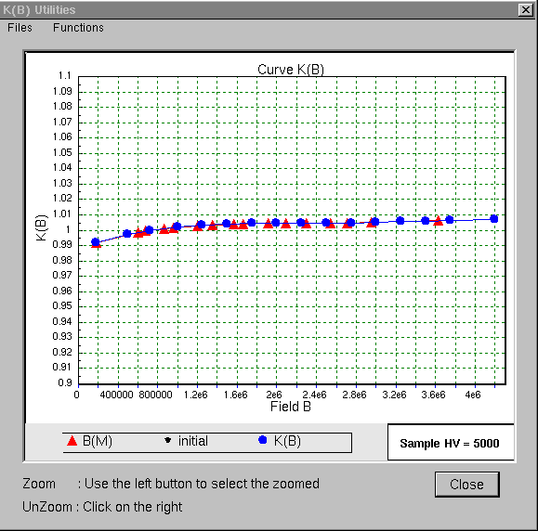

The mass calibration k-B tools window displays:
- the k(B) points (•): B values are read in the abscissa axis and k values in the ordinate axis.
- the B(M) points (▲): B values are read in the abscissa and the k value which corresponds to the B(M) point is read in the ordinate. The k value corresponding to a B(M) point is obtained by inverting relationship (1).
- Straight lines connecting the points are also displayed for clearness sake.
- On the right side of the legend the sample HV value is indicated.

By default, the scale for the k values is set between 0.9 and 1.1 values. A zoom can be performed in the k(B) and B(M) curves. The procedure to zoom in and to zoom out the k(B) and B(M) curves is given below. It is also briefly described on the bottom of k-B tools window.

procedure to apply a zoom in the k(b) and b(m) curves

- Set the mouse cursor in the k(B) curve area of the mass calibration k-B tools window, on the point corresponding to a corner of the area to be zoomed.
- Press the left mouse button. The mouse cursor becomes a drag symbol.
- Drag the mouse cursor. A black colored box is drawn.
- When the box frames the area to be zoomed, release the left mouse button. The boxed area is displayed full window (see figure below).
Note: In order to undo a zoom, press right mouse button on any point of the k(B) curve area.

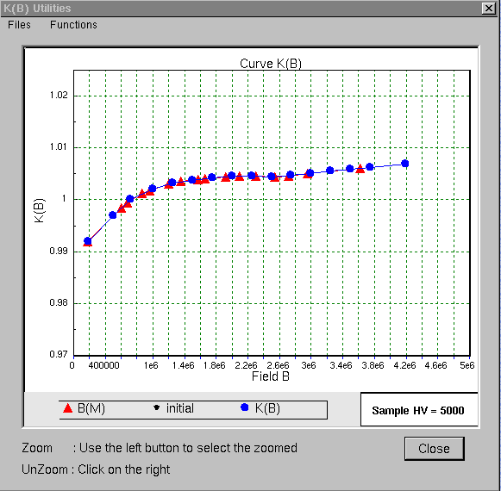

In the k-B tools window two menus are available: files menu and functions menu.

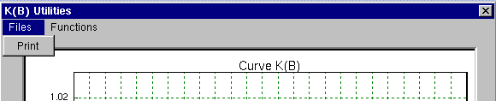

The files menu gives access to the print function: it opens the printing dialog box, which allows the printing of the k(B) and B(M) curves.

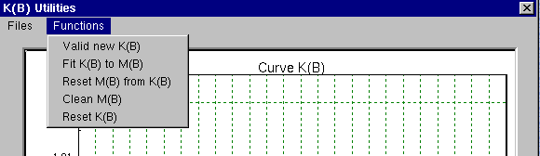

The functions menu gives access to the following functions:

- Valid new k(B). Every k(B) point (•) can be directly modified on the curve by using the mouse: the function valid new k(B) validates the mouse driven points and saves the new k(B) file.
- Fit k(B) to M(B). This function generates the k(B) table by fitting the experimental B(M) points. It is generally used during the factory setting of the instrument only, in order to define the k(B) tables for positive and negative polarity.
- Reset M(B) from k(B). The B(M) table is deduced from the k(B) table and from the sampleHV value, using relationship (1). The B values for 16 integer mass values are computed using a cubic spline interpolation. This function is automatically applied whenever the sampleHV value or the secondary polarity are modified in the Tuning program.
- Clean M(B): all intermediate B(M) points are deleted, the B(M) table keeps the two extreme points only: the B values for the lower and higher mass values.
- Reset k(B): all k(B) points are set equal to 1. This could be a starting point for obtaining a mass calibration if a k(B) table does not exist or if it presents abnormal points.

Note 1: The above functions must be performed carefully since none of them can be undone once the operator answers yes to the confirmation prompt.

Note 2: The function reset k(B) could easily erase a good k(B) file! Backup files named K_B_neg.txt.bak and K_B_pos.txt.bak are saved in directory ims/data/calib. These files contain the k(B) tables with the values that existed before last k(B) operation. For safety reasons, it’s advisable to keep a copy of these files in another directory.

Correction of the mass calibration tables

It must be emphasized that there is always a certain degree of uncertainty in the instrument mass calibration, as explained in the section The M-B memory effect. So that, when calling a given mass M, the B field returned by the main calibration table B(M) should be close, but is hardly exactly, the required magnetic field value to get the mass M at the exit slit center. However, if the returned B field value is very different from the required one, the mass calibration is no longer acceptable and must be corrected. The first step is to check if the mass calibration table can be adjusted by a mass calibration shift (see Procedure to apply a mass calibration shift).
If the shift function does not solve the problem for the whole mass range, it may be necessary to modify the k(B) file. The present k(B) table can be modified point by point by sliding the k(B) points using the mouse (see Procedure to modify the k(B) points by using the mouse), or a new k(B) table can be created by using the reset k(B) function (see Procedure to create a new k(B) table).

Note: in general, it should not be necessary to modify the k(B) tables computed during the factory set of the instrument.

procedure to modify the k(b) points by using the mouse

- Press the left mouse button on the k(B) point (•) to be modified.
- Drag the mouse cursor. The k(B) point (•) follows the cursor.
- When the point reaches the requested position, release the left mouse button. The k(B) point (•) remains in this point.
- If required, repeat the same procedure to move again the same or other k(B) point(s). Until the new k(B) point(s) are validated, the initial k(B) point(s) remain indicated in the graph by the black symbol (•). This allows the operator to easily move back a k(B) point to its initial position.
- Select valid new k(B) in the functions menu of the k-B tools window. A confirmation prompt appears. If the operation is confirmed, the new k(B) points are validated and the k(B) table is overwritten.
- If required, the B(M) table can be regenerated from this new k(B) table by selecting Reset M(B) from k(B) in the functions menu of the k-B tools window.

procedure to create a new k(b) table (expert level)

- Select reset k(B) in the functions menu of the k-B tools window, in order to set all k(B) points equal to 1.
- Select Reset M(B) from k(B) to initialize the B(M) table. These first two steps can be skipped if the previous B(M) table gives a sufficiently good mass calibration.
- For each one of the masses stored in the B(M) table, find the correct B field that sets the that mass M at the exit slit center, and store the new B field value by a mass calibration action (using direct calib in the Tuning program or calling the mass calibration routine).
- Delete the B(M) point(s) for masses which cannot be measured and/or add points for masses which can be tested experimentally. The important point is that at the end of this procedure, the B(M) table should contain only experimentally obtained B field values. Also, these points should cover as uniformly as possible the whole mass range.
- Select Fit k(B) to M(B) in the functions menu of the k-B tools window, to compute the new k(B) table from the B(M) points. A confirmation prompt appears. If the operation is confirmed, the previous k(B) table is overwritten with the new values.
- If required, the B(M) table can be regenerated from this new k(B) table by selecting Reset M(B) from k(B) in the functions menu of the k-B tools window.

Contents ↑

Mass calibration routine: mass cal window

The mass calibration routine is used mostly before starting an analysis. In the Analysis program, the initial magnetic field value assigned to the masses entered by the operator is calculated using the B(M) table. Before starting the measurement, however, the magnetic field value must be determined as precisely as possible using the mass calibration routine. This routine can also be applied to calibrate the mass entered in the Mass & Slits box of the Tuning program.

The procedures are identical independently of the program, Analysis or Tuning, that calls the mass calibration routine. Main differences concern:
- the number of masses to calibrate. If the routine is called from Analysis, all masses defined in the species table of the Analysis program are taken into account, whereas if it is called from Tuning, only the mass entered in the Mass & Slits box is calibrated.
- the destination of the output magnetic field values. If the routine is called from Analysis, the output B values are returned to the species table b(m) of the Analysis program and may or not be saved in the B(M) table (see The analysis mass calibration b(m) table). If the routine is called from Tuning, the new B values fill the B(M) table only.

Three mass calibration modes are proposed to the operator:
- The manual mode: invites the operator to tune manually the B field by means of the mass keyboard thumbwheel for each mass.
- The semi-auto mode: scans the B field for each mass, displays the spectrum and invites the operator either to set the B field by mouse driving a cursor on the spectrum or by using an auto center routine. This mode is very commonly used to calibrate the masses before starting an analysis.
- The automatic mode scans the B field for each mass, displays the spectrum and automatically determines the B field for each mass.

In the manual mode, the magnetic field setting can be controlled using either the counting system (EM or FC) or the micro-channel plate image (Slit or Image mode), whereas in the semi-auto and automatic mode, the operator can control the magnetic field setting using the counting system (EM or FC) only.
Whenever the counting system is used, the switching EM/FC and FC/EM during the mass calibration routine obeys the rules of the parent program, Tuning or Analysis, that has called the mass calibration program. For the EM/FC switching, refer to the secondary ion optics user's manual.

When called from the Analysis program, the mass calibration routine is launched with the Optional Instrument Parameters (OIP) which have been set in the analysis definition. However, the OIP can be modified at any moment during the mass calibration routine using directly the Tuning program. For instance, if one of the analyzed species is present mostly near the surface, the operator may set, during the mass calibration routine, no electronic gating (100%) and DTOS ON. The conditions defined in Analysis are not affected by the modifications achieved during the mass calibration process. After the mass calibration is completed, and when launching the analysis acquisition, the OIP set in the analysis definition are sent again to the Tuning program.

Note: The exit slit width determines the mass resolution value, and therefore the mass range scanned around each mass, as explained below. When changing the exit slit width during the mass calibration routine, the value of mass resolution is not automatically updated. To apply the new exit slit value, the mass calibration program must be closed, and opened again once the new value of exit slit width has been read from Tuning and set in the analysis definition.

Procedure to start a mass calibration

- Select the calib now function in the calib menu of the Analysis program, or the call calib function in the calib menu of the Tuning Mass & Slits preset box.
- If required, press mass cal button in the mass calibration window.
- Select the mass calibration mode by pressing either manual, semi-auto, or automatic button.

Contents ↑

Manual mode

In the manual mode, the operator tunes manually the B field by means of the mass keyboard thumbwheel for each mass.

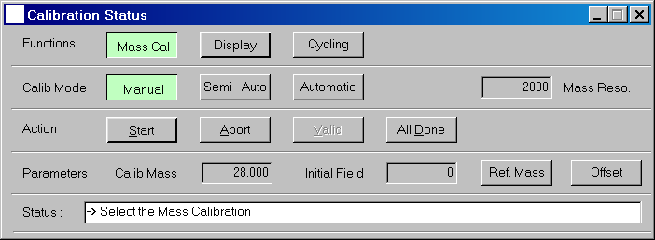

Action buttons: start, abort, valid, all done

Four action buttons are available:
  - Start button: starts the mass calibration routine.
  - Abort button: stops the mass calibration routine. The B(M) table is not updated even if some masses have already been calibrated (valid button).
  - Valid button: locks the current magnetic field value to the mass being calibrated. This B field value is not yet transmitted to the analysis species table and/or main mass table. If there are other masses to calibrate, the magnetic field value currently assigned to the next mass is sent to the instrument interface.
  - All done button: confirms the mass calibration routine. The (M,B) values which have already been calibrated with the valid button are written in the mass calibration tables. The mass calibration program closes.

Note : The all done function can be activated at any time. If it is activated during the mass calibration routine, the B field values which have already been calibrated are written in the B(M) table.

Display fields

On the right side of the window, the mass reso. field displays the indicative mass resolution calculated from the exit slit width.

Parameters calib and initial field:
- calib field: displays the value of the mass being calibrated.
- initial field: displays the B field value read on the magnetic field interface.
When the mass calibration program opens, the initial field for each mass is the B field value assigned to that mass, computed from the current mass calibration table B(M).

Status box: displays messages to guide the operator in performing the mass calibration routine.

Mass calibration options : offset

The offset function allows to choose whether to apply or not a sample voltage offset during the mass calibration for each mass, if an offset as been defined in the Tuning or the Analysis programs.

The offset button opens the offset window. The status of the offset option must be set before starting the mass calibration procedure.

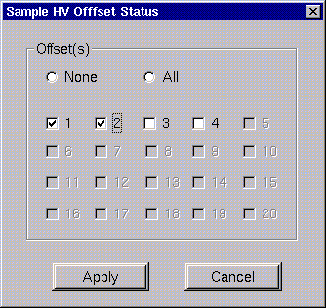

Only masses with checked boxes are calibrated with the offset defined in Tuning or Analysis. Click all to select all masses, or none to unselect all masses. By default, none of the masses is selected.

Buttons:
- apply: confirms the offset selection and closes the offset window.
- cancel: erases the offset selection and closes the offset window. No changes are kept.

Procedure in manual mode

procedure to perform a mass calibration in the manual mode

- Once the mass calibration program is opened, press mass cal button.
- Select the manual calibration mode by pressing manual button.
- Press start button to start the mass calibration routine. The primary beam is turned ON. The mass being calibrated and the field initially assigned to it are displayed in the calib and initial field fields.
- Using the mass keyboard thumbwheel, tune the magnetic field value.
- Press valid button to assign the selected magnetic field to the mass to calibrate.
- If there are other masses to calibrate, the magnetic field currently assigned to the next mass is sent to the instrument interface. Repeat from step #4. When all masses are calibrated, the primary beam is automatically turned OFF.
- Press all done button to confirm the overall mass calibration procedure. The validated (M,B) couples are transmitted to the analysis species table and/or the main mass table. The all done function can be used even if the mass calibration routine is not finished yet.

Note: The manual calibration procedure can be cancelled at any time by pressing the abort button. None of the previously validated (M,B) points are kept.

Contents ↑

Semi-auto mode

During the semi-auto mass calibration procedure:
  - The magnetic field is cycled over all masses defined in the Analysis species table. The waiting time for each mass switch is set to 0.160 ms (it cannot be changed by operator).
  - The magnetic field is scanned around each mass to be calibrated.
  - The mass spectrum curve is displayed for each mass in the bottom of the mass cal window.
  - The peak centering is performed by the operator either by mouse driving a cursor on the spectrum or by using an auto center routine.

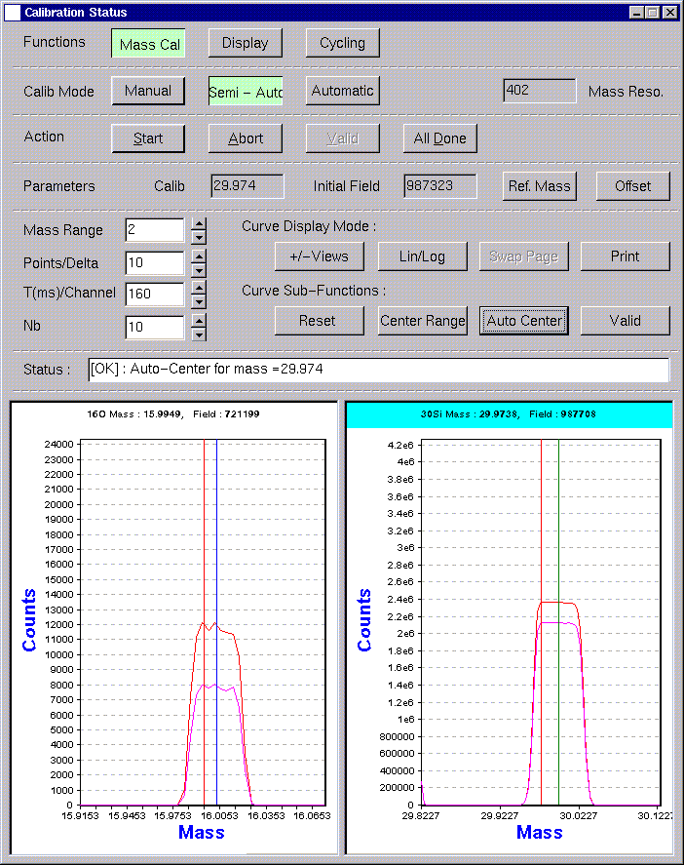

Rules for the mass spectrum windows display

- The number of mass windows is automatically adjusted as a function of the number of masses to be analyzed. If the number is higher than 10 there will be 2 pages.
- The mass spectrum curve shows the intensity vs. magnetic field in mass units. The conversion from magnetic field B to mass M is given by the table B(M) (see The k(B) and B(M) tables).
- The curve plotted at the end of the n^{th} cycle is the cumulated data of the n first curves.
- On the top of each mass window, the mass to be calibrated M and the magnetic field corresponding to the position of the vertical green cursor are displayed.
- The semi-auto routine works with the concept of selected mass: a mass is selected by clicking on the corresponding mass spectrum window. The selected mass window is indicated with a blue stripe.
- There are four types of cursors in the semi-auto mode:

Red cursors:
They indicate the center of the magnetic field scanning for each mass. They are centered in the mass window (when no reference mass is selected). At the beginning of a new mass calibration procedure, they are placed in the mass calibration point corresponding to the previous mass calibration. A new center for the mass scan can be defined by a center range operation: the B field value assigned to the red cursor is modified and the mass axis scale updated to keep the red cursor in the center of the mass window. The current position of the red cursor in the selected mass window is displayed in bit units in the initial field field.

Green cursor:
It is displayed in the selected mass window only. It is used to select the value of the B field corresponding to a new scanning center or to a new mass calibration point. The green cursor is placed by default on the red cursor position. The green cursor position can be modified either by clicking auto center or by clicking middle mouse button after setting the mouse pointer on the required cursor position. The current position of the green cursor is given in bits units in the header of the selected mass window.

Yellow cursor:
It is displayed in combination with the green cursor only when the reference mass option is used. The green cursor corresponds to the reference species and the yellow cursor to the species to be analyzed.

Blue cursors:
They show the results of a new mass calibration. For every mass window, when clicking valid, the cursor color toggles from green to blue.

Action buttons: start, abort, all done

The following action buttons are available:
  - Start button: starts the mass calibration routine. The mass spectrum recorded for each mass is sequentially displayed in the different mass windows.
  - Abort button: stops the mass calibration routine. The B(M) table is not updated even if some masses have already been calibrated (valid button).
  - All done button: The (M,B) values which have already been calibrated with the valid button are written in the mass calibration tables. The mass calibration program closes.

Note 1: The all done function can be activated at any time. If it is activated during the mass calibration routine, the B field values which have already been calibrated are written in the B(M) table. The current cycle is always completed before the all done function takes effect.

Note 2: For the semi-auto mode, the valid button is placed in the curve sub-functions line (see below).

Display fields

On the right side of the window, the mass reso. field displays the indicative mass resolution calculated from the exit slit width.

Parameters calib and initial field:
- calib field: displays the value of the selected mass.
- initial field: displays the B field value corresponding to the center of the magnetic field scanning (red cursor) for the selected mass.
When the mass calibration program opens, the initial field for each mass is the B field value assigned to that mass, computed from the current mass calibration table B(M).

Status box: displays messages to guide the operator in performing the mass calibration routine.

Mass calibration options : offset

The offset function allows to choose whether to apply or not a sample voltage offset during the mass calibration for each mass, if an offset as been defined in the Tuning or the Analysis programs.

The offset button opens the offset window. The status of the offset option must be set before starting the mass calibration procedure.

Only masses with checked boxes are calibrated with the offset defined in Tuning or Analysis. Click all to select all masses, or none to unselect all masses. By default, none of the masses is selected.

Buttons:
- apply: confirms the offset selection and closes the offset window.
- cancel: erases the offset selection and closes the offset window. No changes are kept.

Mass calibration options : reference mass

The reference mass option allows to use a reference peak (high intensity) in order to perform an accurate mass calibration for a low intensity peak. For instance, if the mass to be analyzed is P at trace level in silicon, the SiH peak will probably have a much higher intensity than P. An accurate peak centering will be therefore easier to be carried out on SiH than on P. The reference mass option allows the operator to perform the peak centering on the SiH peak, and the system will automatically apply the right magnetic field offset to obtain the magnetic field value corresponding to the analyzed species P.

The Ref. Mass button opens the reference mass window, which allows to enter a reference mass for any of the analyzed species. The status of the reference mass option must be set before starting the mass calibration procedure.

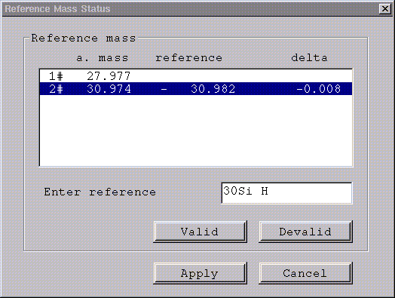

Display fields:
- a. mass: list of all species to be analyzed.
- reference: list of the exact mass of the reference species already defined by the operator.
- delta: mass of the reference species – mass of the species to be analyzed.

Enter fields:
- enter reference: field to type the symbol or the exact mass of the reference species. This field is also used to display the symbol corresponding to a reference mass, when clicking on the corresponding reference mass line.

Buttons:
- valid: confirms the reference mass definition for the selected a. species.
- devalid: erases the reference mass for the selected a. species.
- apply: confirms all reference mass definitions and closes the reference mass window.
- cancel: closes the reference mass window, no changes are kept.

procedure to enter a reference mass

- Press the Ref. Mass button in the mass cal window. The reference mass dialog box opens.
- Click on the line corresponding to the analyzed mass for which a reference mass will be defined.
- Enter the reference mass in the enter reference editing field. Symbols are allowed.
- Press valid button to validate the reference mass. The reference mass value and the difference between the analyzed mass and the reference mass are displayed in the delta column. Press devalid button to undo.
- Press apply button to close the reference mass and to apply the selected settings, or cancel button to close the reference mass window without keeping the reference mass selection.

After applying the reference mass selection shown in the above figure, the mass calib window shows two cursors in the P display window:
- Red cursor: indicates the B field value currently assigned to the reference mass (SiH).
- Yellow cursor: indicates the B field value currently assigned to the analyzed species (P).
Note: When a reference mass is used, the default value for the central point of the mass scan is the mass of the reference species and not the mass of the species to be analyzed.

If the P window becomes the selected mass window, a green cursor is automatically placed over the red cursor. Whenever the green cursor for the reference mass is moved either by an auto center operation or by a middle mouse button click on the mass spectrum, the position corresponding to the analyzed species (yellow cursor) follows in order to keep the mass difference delta.

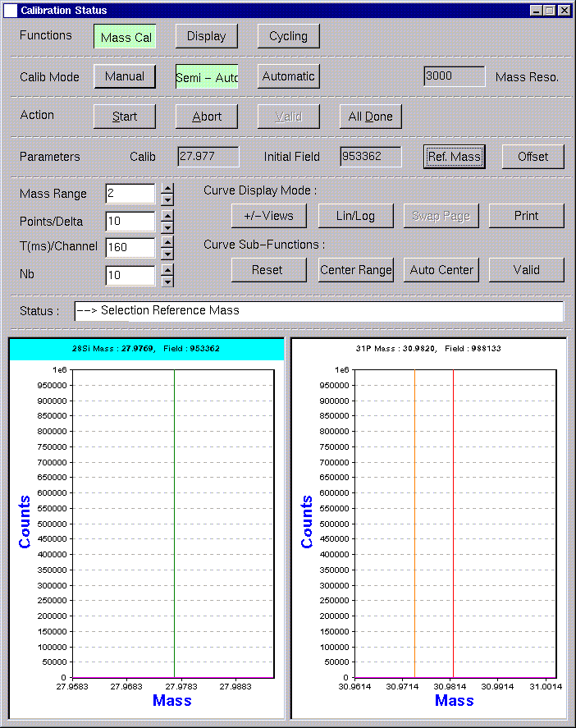
Mass calibration parameters for the B field scan

The magnetic field scanning around the initial field value (red cursor) is defined for each mass with the scanning parameters displayed in the fields Mass range, Points/Delta, and T(ms)/Channel. Independent values of these parameters can be set for the different analyzed species. Only the parameter Nb applies to all mass spectrum windows.

- Mass range: number of Δm scanned before and after the initial field value. For a mass range set to N, the magnetic field is scanned between the values corresponding to masses M(initial field)–N*Δm and M(initial field)+N*Δm. Δm is defined as M/mass resolution, where M is analyzed mass value and mass resolution the indicative mass resolution value displayed in the mass reso. field. The default value is 2.

- Points/Delta: number of data points per Δm interval. The default value is 10.

- T(ms)/Channel: counting time (in ms) for each measured data point. The default value is 160 ms (two frames).

- Nb: number of magnetic field cycles. If several masses are calibrated (M₁,…, M_{N}), the routine performs Nb complete cycles (M₁,…, M_{N}), (M₁,…, M_{N}) and so on, each mass being scanned around mass M. The default value is 10.

The operator may modify the default values by typing the new values directly in the corresponding editing fields or by incrementing the old value with the increment buttons. The values can be modified either before or during the magnetic field cycling. The new values are taken into account for the data acquisition only after pressing reset.

- Reset button: applies the new calibration parameters to the selected mass (the new Nb value is applied to the all masses). Pressing reset executes also a reset of the intensity vs. mass plot.

procedure to modify the b field scan parameters

- Click the mass window for which the parameters are to be modified.
- Change the parameter values by typing the new values directly in the corresponding editing fields or by incrementing the old value with the increment buttons.
- Press reset button.

Curve display options

Curve display mode buttons:
- +/- views: switches between two different display modes, if several masses are being calibrated: either all mass windows are displayed or just the selected mass window (indicated with a blue stripe).
- Lin/log: switches between logarithm and linear scale, it is applied to the selected mass spectrum only.
- Swap page: If the number of analyzed species is higher than 10, there will be two mass window pages. Swap page allows to switch between the two pages.
- Print: opens the printing dialog box, it allows the printing of the selected mass window. It is not available during the mass calibration routine.

Auto center

This function executes an automatic determination of the center of the maximum intensity peak displayed in the selected mass window. The selected magnetic field is indicated by a green cursor.

Centering algorithm:
- Determination of the maximum intensity value I_{M} in the mass spectrum plot.
- Determination of the B²₁ and B²₂ values corresponding to half of the maximum intensity I_{M}/2, on both sides of the peak.
- The center of the peak is set at B²_{c} = (B²₁ + B²₂)/2.

auto center procedure

- Click the mass window with a peak center to be determined.
- Press auto center button. The green cursor is automatically set to the position corresponding to B²_{c}. In case of mass calibration with a mass reference, two cursors will be displayed: green for the reference, yellow for the mass to be calibrated.
- The position of the green cursor can be modified by means of the mouse: set the mouse pointer on the required cursor position and click middle mouse button. The cursor moves to the new position.

Center range

This function executes a shift on the mass range scanned for the selected mass. The new center of the mass scan must be previously selected by driving the green cursor onto the required position.

center range procedure

- Click the mass window with a mass scan to be re-centered.
Either:
- Set the mouse pointer onto a particular point of the mass scale you want to become the center of the next mass scan, and click middle mouse button. The green cursor moves to this new position.
Or:
- Press auto center button. The green cursor is automatically set to the position corresponding to B²_{c}.
- Click center range to execute the mass scan shift. The mass axis scale and the red cursor position are updated accordingly to the new scanned mass range. The initial field value gives the magnetic field value corresponding to the red cursor position.

Action buttons: valid

  - Valid button: locks the magnetic field value corresponding to the current position of the green cursor to the mass being calibrated. This B field value is not yet transmitted to the analysis species table and main mass table. The cursor color toggles from green to blue.

Note: The validated values are transmitted to the analysis species table and main mass table, only when the all done function is used.

Once a given mass is validated, the magnet is still cycled over that mass, complying with the waiting time, but the B field scan around that mass is no longer performed. So that, there is no updates of the intensity vs. mass plot in a mass window with a blue cursor. When all the masses are validated, and if the number of cycles defined by the operator (Nb) are not yet completed, the cycling over all the masses is performed until completing the Nb cycles.

For a given mass window, a miss-calibration can be corrected by validating a new B field value. If several B field values are validated in the same window, only the last value is kept and sent to the mass calibration tables when using later the all done function. However, the mass scan around that mass stops after the first valid.
It remains always the possibility of using the abort function. In this case, all previously validated (M,B) points are lost. The mass calibration procedure can then be restarted by pressing the start button.

Procedure in semi-auto mode

procedure to perform a mass calibration in the semi-auto mode

- Once the mass calibration program is opened, press mass cal button.
- Select the semi-auto calibration mode by pressing semi-auto button.
- If required, use the reference mass option. The reference mass dialog box can be opened by pressing the ref. mass button.
- If required, use the offset option. The offset dialog box can be opened by pressing the offset button.
- Check the total number of cycles Nb and the magnetic field scanning conditions for each mass: Mass range, Points/Delta, T(ms)/Channel. If required, modify these conditions either by editing the values with the keyboard or by using the increment buttons. Validate the new values for each mass window by pressing reset button.
- Press start button to start the mass calibration routine. Automatically, the primary beam is turned ON and the magnetic field is scanned for each mass according to the scanning conditions. The mass spectra are displayed in the bottom of the mass calibration window. The curve plotted at the end of the n^{th} cycle is the cumulated data of the n first curves (as long as the center range or reset functions are not used).
- If several masses are being calibrated, select one of the masses by clicking the corresponding mass spectrum window. The selected mass window is indicated with a blue stripe.
- If required, change the display of the selected mass window by using the +/- views or lin/log functions.
- If required, shift the B field scanning range by using the center range function.
- If required, press reset button to execute a reset of the intensity vs. mass plot for the selected mass.
- When you feel enough data has been acquired, set the magnetic field for the selected mass, either by mouse placing a cursor onto a mass spectrum point (middle mouse button click), or by using the auto center routine.
- Press the valid button to lock the magnetic field value corresponding to the green cursor position to the selected mass. The cursor color toggles from green to blue.
- Repeat the same procedure from step#7 for each mass. The calibration routine stops when the Nb cycles defined by the operator are completed. The print option can then be used.
- Press all done button to confirm the overall mass calibration procedure. The already validated (M,B) couples are transmitted to the analysis species table and/or the main mass table. The all done function can be used even if the mass calibration routine is not finished yet.

Note 1: If required, the semi-auto calibration procedure can be cancelled by pressing abort button. None of the previously validated (M,B) points are kept.

Note 2: The magnetic field scanning conditions can also be modified during the mass calibration procedure. The button reset must be pressed to validate the new conditions.

Contents ↑

Automatic mode

The procedures for the automatic mode are essentially the same as for the semi-auto mode, with the difference that here they are automatically chained from the start to the all done steps. The B field is automatically validated for each mass using the auto center routine.

The only command available for the automatic mode is abort. This means, that, contrary to the semi-auto mode, all parameters must be defined before starting the mass calibration routine.

Parameters in the automatic mode

- The offset and reference mass options are available in the automatic mode.
- The operator has no access to auto center and valid. They are under computer control.
- The center range function does not exist.
- The operator can still select a given mass window, and modify the windows display using the functions +/- views, lin/log, or swap page (if available).

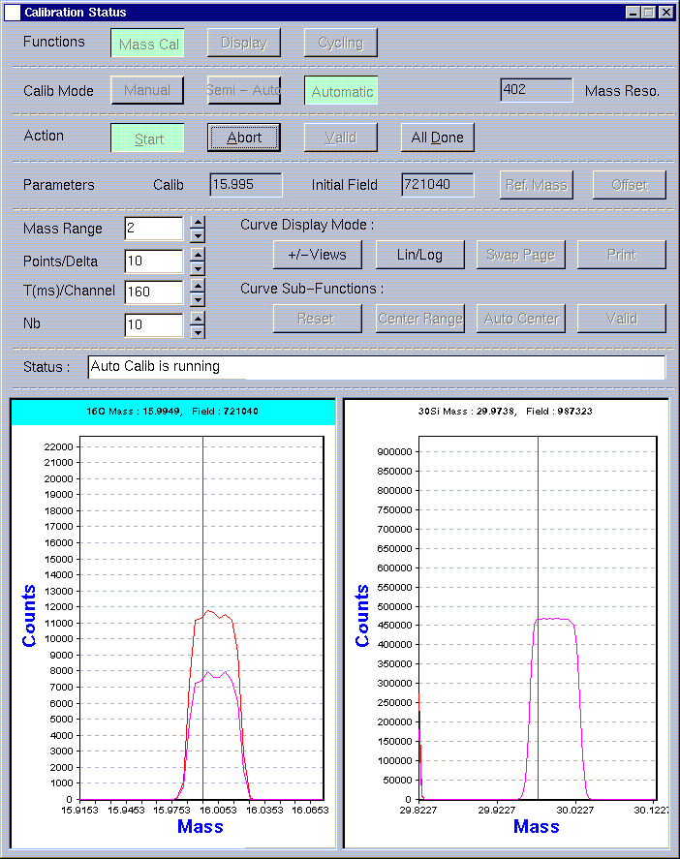

Procedure in automatic mode

procedure to perform a mass calibration in the automatic mode

- Once the mass calibration program is opened, press mass cal button.
- Select the automatic calibration mode by pressing automatic button.
- If required, use the reference mass option. The reference mass dialog box can be opened by pressing the ref. mass button.
- If required, use the offset option. The offset dialog box can be opened by pressing the offset button.
- Check the total number of cycles Nb and the magnetic field scanning conditions for each mass: Mass range, Points/Delta, T(ms)/Channel. If required, modify these conditions either by editing the values with the keyboard or by using the increment buttons. Validate the new values for each mass window by pressing reset button.
- Press start button to start the mass calibration routine. Automatically, the primary beam is turned ON and the magnetic field is scanned for each mass according to the scanning conditions. The mass spectra are displayed in the bottom of the mass calibration window. The curve plotted at the end of the n^{th} cycle is the cumulated data of the n first curves.
- If several masses are being calibrated, one of the masses may be selected by clicking the corresponding mass spectrum window. The selected mass window is indicated with a blue stripe.
- If required, change the display of the selected mass window by using the +/- views or lin/log functions.
- At the end of the magnetic field cycling (Nb cycles completed), the magnetic field is automatically set in the center of the mass peak for each mass using the auto center routine, and then validated.
- Press all done button to confirm the overall mass calibration procedure. The validated (M,B) couples are transmitted to the analysis species table and/or the main mass table.

Note 1: If required, the automatic calibration procedure can be cancelled by pressing abort button. None of the previously validated (M,B) points are kept.

Note 2: In the automatic mode, if the all done function is used before the end of the mass calibration routine, the mass calibration program closes but no (M,B) point is validated since the validation is performed only at the end of the Nb cycles.

Contents ↑

Mass calibration cycling window

The cycling function allows to cycle the magnetic field for (B_{min}, B₂... B_{i},... B_{max}) corresponding to the masses defined in the analysis table (M₁,M₂,…M_{i},…M_{N}). As explained in the section The cycling strategy, after a few number of cycles, the mass value produced at the exit axis reaches a steady state, reducing in this way the uncertainty in the determination of the B field value for each mass.

The mass calibration program must be opened from the Analysis program. During the cycling procedure, the waiting time for each mass switch is set to 0.160 ms (it cannot be changed by operator).

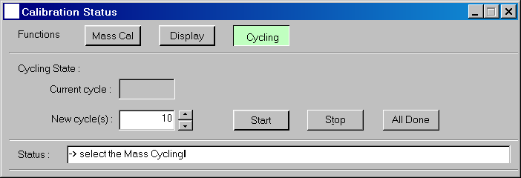

- Current cycle read-only field: displays the current cycle if the cycling routine is running.
- New cycle: editable field which defines the number of cycles to be performed.
- Start: starts the cycling routine.
- Stop: stops the cycling routine.
- All done: closes the mass calibration program.

procedure to use the cycling option

- Once the mass calibration program is opened, press cycling button.
- Check the number of cycles to be performed in the new cycle field value. If required, modify the number of cycles either by editing the value with the keyboard or by using the increment buttons.
- Press start button to start the cycling routine. Automatically, the primary beam is turned ON, and the magnetic field is cycled over the masses entered by the operator in the Analysis table.
- If required, stop the cycling routine by pressing stop button. Else, at the end of the magnetic field cycling, the cycling routine stops.

Contents ↑

